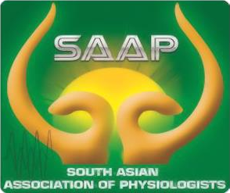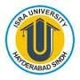 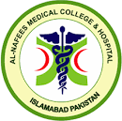 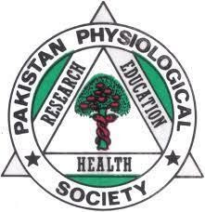

**Third Regional Journal Club**

**Pakistan Physiological Society**

**Rawalpindi & Islamabad Twin cities**

**Topic:** Physiological effects of high-intensity versus low-intensity noninvasive positive pressure ventilation in patients with acute exacerbation of chronic obstructive pulmonary disease: a randomized controlled trial

Presenter: Muhammad Usman Hashmi

Supervisor: Prof. Dr. Samia Sarwar

Institute: Rawalpindi Medical University

Day/ Date: Friday, 24th May 2024.

Venue: Al- Nafees Medical College, Isra University Islamabad Campus, Lehtrar road, Farash town

Timings: 10:00 am to 11:00 am (20 minutes presentation and 40 minutes discussion time)

Mode: Hybrid (Google meet link will be shared later)

Moderador: Prof. Dr. Munazza Asad.

Closing remarks: Prof Dr Umar Ali Khan Pro Vice Chancellor Isra University

Participants: All faculty of Physiology from Medical Colleges of Rawalpindi & Islamabad are cordially invited to attend the Journal club on above venue.

For any query: email at [munazza_wah@yahoo.com](mailto:munazza_wah@yahoo.com)